**Cyber Security**

**Assignment Day 4**

**Question 1:**

# 1.Find out the mail servers of the following domain:

# IBM.com

# Wipro.com

Open PenTester VMware workstation

Open Command Prompt

Type:

ipconfig

nslookup

www.Ibm.com

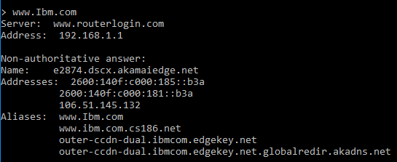

www.Wipro.com

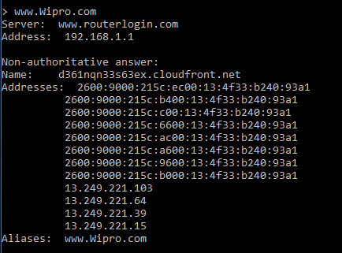

**Question 2:**

**Find the locations, where these email servers are hosted.**

Cont. of Question 1

Type:

set type=mx

Ibm.com

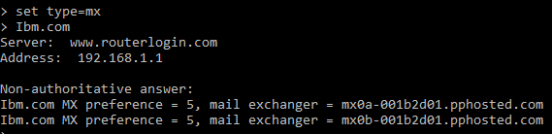

Open google chrome

Open IP Location Finder

Copy paste the url and find the location

**Address 1:**

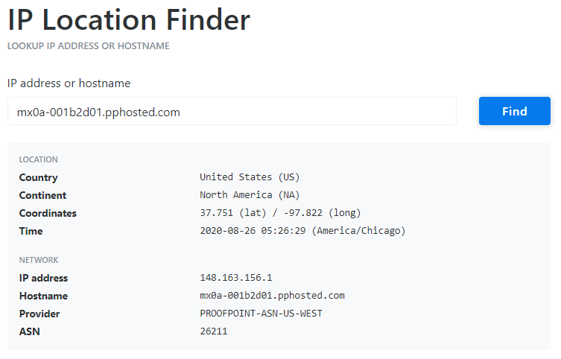

**Address 2:**

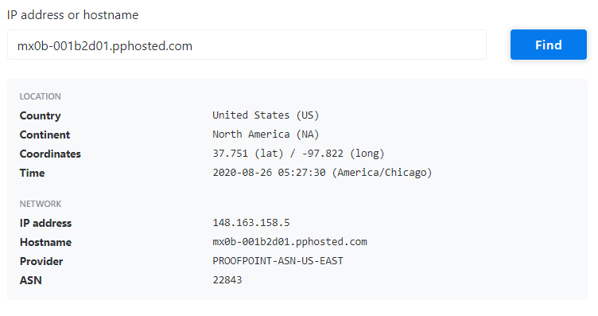

Wipro.com

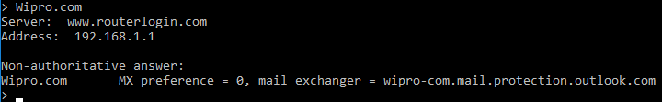

Open google chrome

Open IP Location Finder

Copy paste the URL and find the location

**Address:**

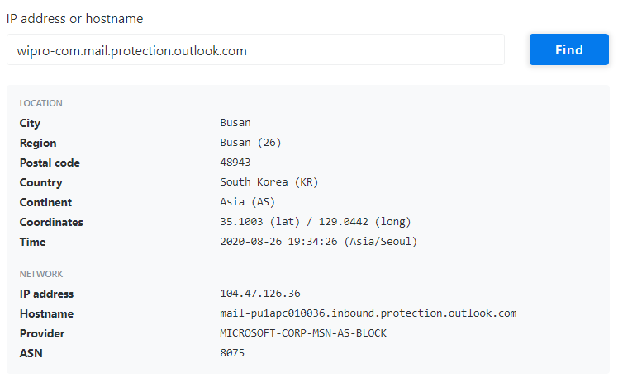

**Question 3:**

**Scan and find out port numbers open 203.163.246.23**

Open Kali-pc

Right click on the screen and Open Terminal

Type:

sudo su –

Enter password

Enter – nmap –Pn –sS 203.163.246.23

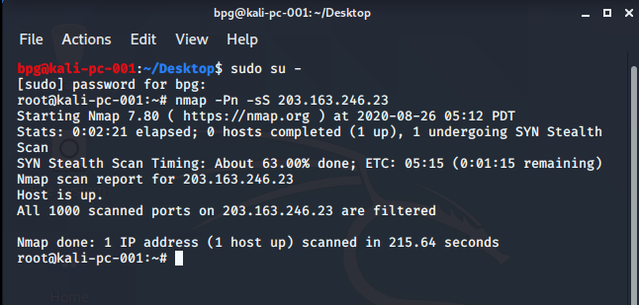

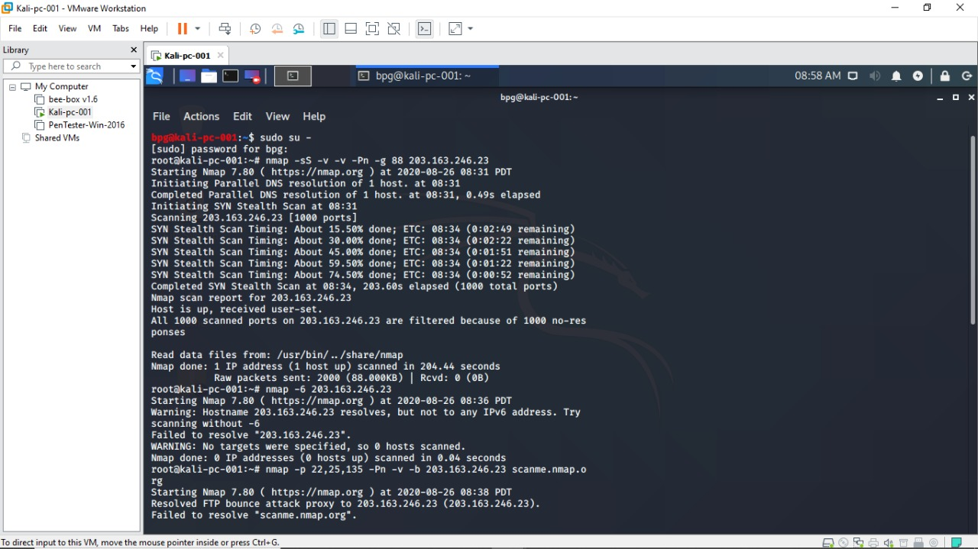

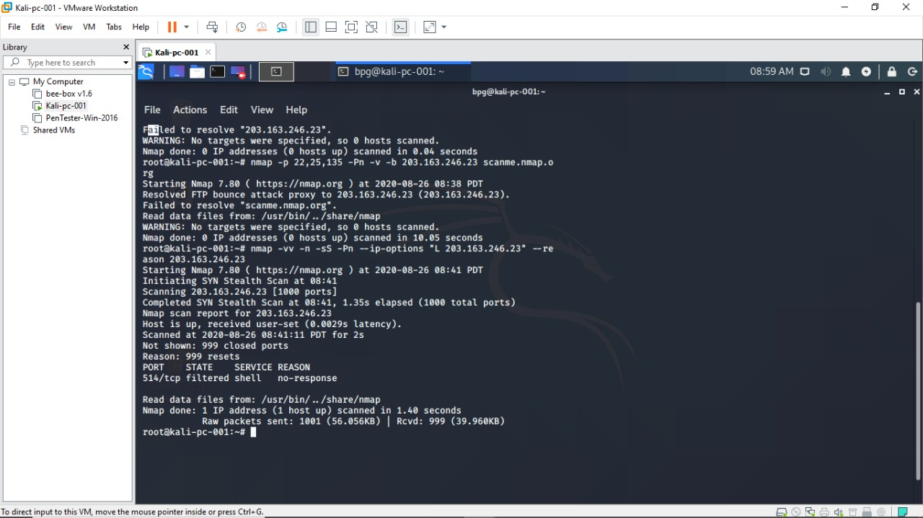

**Question 4:**

**Install nessus in a VM and scan your laptop/desktop for CVE**

Open PenTester VMware workstation

Install Google Chrome

Install Nessus

Click on All scans Create a new scan Advance settings Windows Fill the required blanks in credentials as well Launch

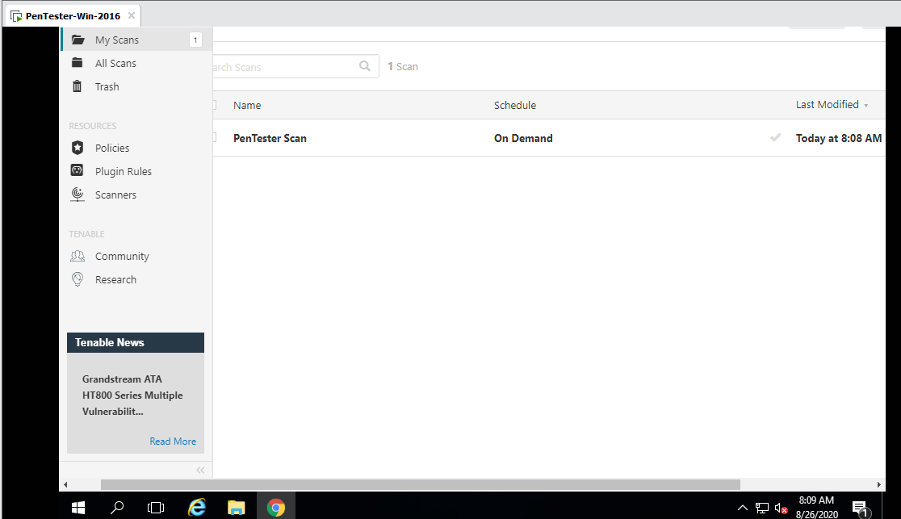

Report:

